Mathematics 3A

Examination

Section One:
Calculator-free

Time allowed for this section
Reading time before commencing work: 5 minutes
Working time for this section: 50 minutes

Material required/recommended for this section
To be provided by the supervisor
This Question/Answer booklet
Formula sheet

To be provided by the candidate
Standard items: pens, pencils, pencil sharpener, eraser, correction fluid, ruler, highlighters

Special items: nil

Important note to candidates
No other items may be used in this section of the examination. It is your responsibility to ensure that you do not have any unauthorised notes or other items of a non-personal nature in the examination room. If you have any unauthorised material with you, hand it to the supervisor before reading any further.

Structure of this paper

Section | Number of questions available | Number of questions to be answered | Working time (minutes) | Marks available
Section One:  Calculator-free | 7 | 7 | 50 | 40
Section two: Calculator assumed | 8 | 8 | 100 | 80
 |  |  |  | 120

Instructions to candidates

1. The rules of conduct of school exams should be known to you. Sitting this exam implies you agree to abide by these rules.

2. Write your answers in the spaces provided in this Question/Answer Booklet. Spare pages are included at the end of this booklet. They can be used for planning your responses and/or as additional space if required to continue an answer.
- Planning: If you use spare pages for planning, indicate this clearly at the top of the page
- Continuing an answer: If you need the space to continue an answer, indicate in the original answer space where the answer is continued, i.e. give the page number. Fill in the number of the question(s) that you are continuing to answer at the top of the page.

3. Show all your working clearly. Your working should be sufficient to allow your answers to be checked readily and for marks to be awarded for reasoning. Incorrect answers given without supporting reasoning cannot be allocated any marks. For any question or part question worth more than two marks, valid working or justification is required to receive full marks. If you repeat an answer to any question, ensure that you cancel the answer you do not wish to have marked.

4. It is recommended that you do not use pencil except in diagrams.

Section One: Calculator-free

This section has seven (7) questions. Answer all questions. Write your answers in the space provided.

Spare pages are included at the end of this booklet. They can be used for planning your responses and/or as additional space if required to continue an answer.
- Planning: If you use spare pages for planning, indicate this clearly at the top of the page
- Continuing an answer: If you need the space to continue an answer, indicate in the original answer space where the answer is continued, i.e. give the page number. Fill in the number of the question(s) that you are continuing to answer at the top of the page.

Suggested working time for this section is 50 minutes.

Question 1 (4 marks)

On the number line below draw diagrams representing two normal distributions A and B with the following statistics:

Normal distribution A is to be shown with a mean of 50 units and standard deviation of 5 units.

Normal distribution B is to be shown with a mean of 60 units and standard deviation of 10 units.

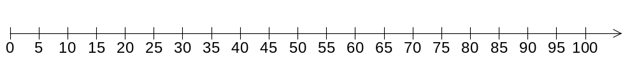

Question 2 (5 marks)

In a team of walkers there are 3 ladies and 4 gentlemen. None of them have the same name. They have arrived at a lunch spot and are delighted to find that there is someone there who agrees to take a group photo for them. They decide to make two rows in the photo, the ladies crouching down in the front with the gentlemen standing behind.

Determine the following leaving your answer in factorial form:

(a) How many different arrangements are there for the back row? (1 mark)

(b) How many different arrangements are there for the front row? (1 mark)

(c) How many different arrangements are there for the photo? (1 mark)

(d) How many different arrangements are there if Jane must stand next to Mary and Craig next to Daniel? (2 marks)

Question 3 (8 marks)

Given the sequence defined by 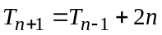 and with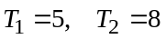;

(a) Write down the first five terms of the sequence. (3 marks)

(b) What would the sum of the first ten terms be? (5 marks)

Question 4 (6 marks)

Rank the following six graphs in ascending order according to their;

(a) mean

(b) standard deviation

(Each set of data consists of 5 scores)

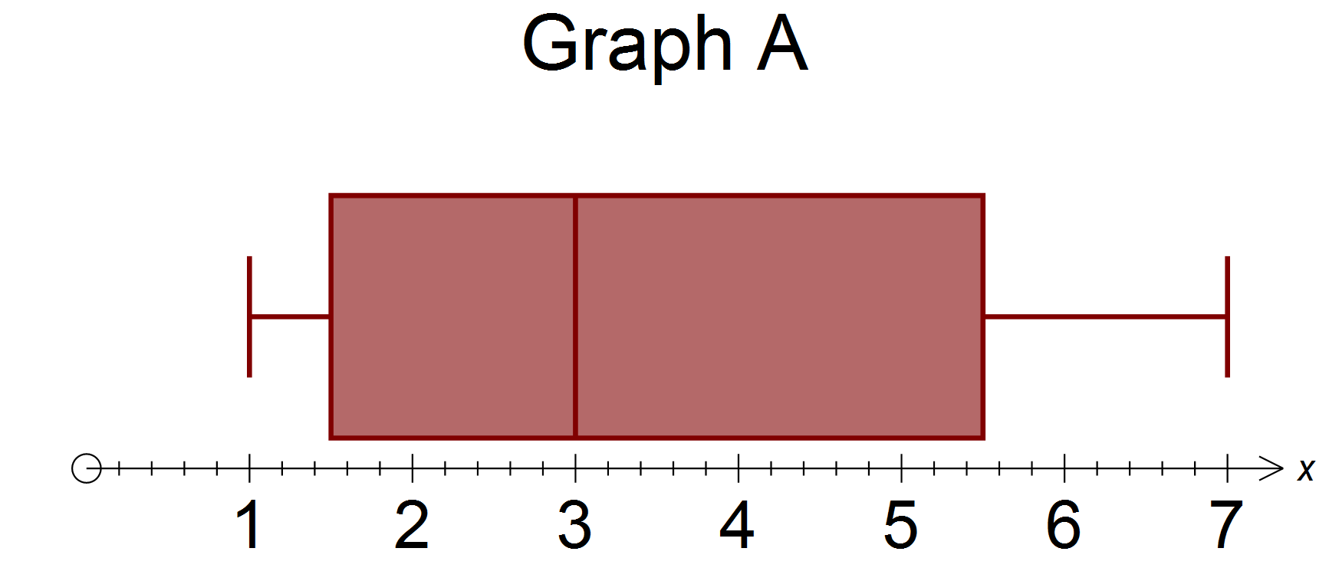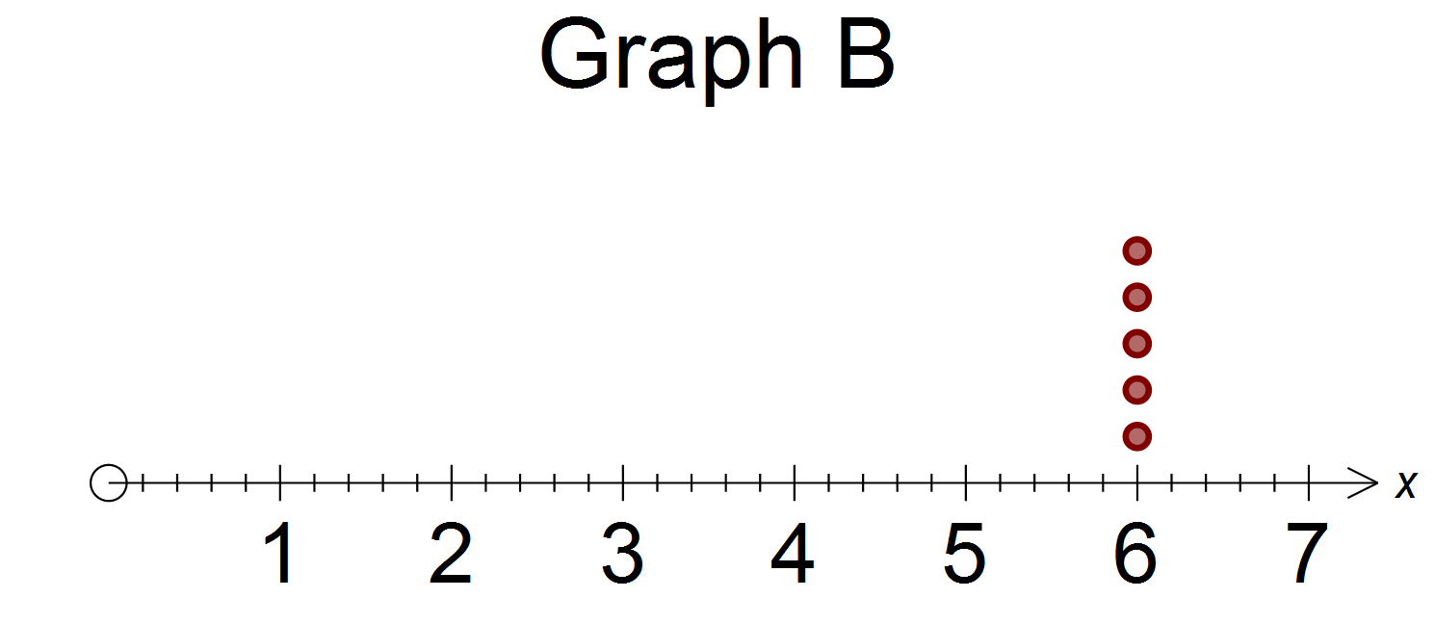

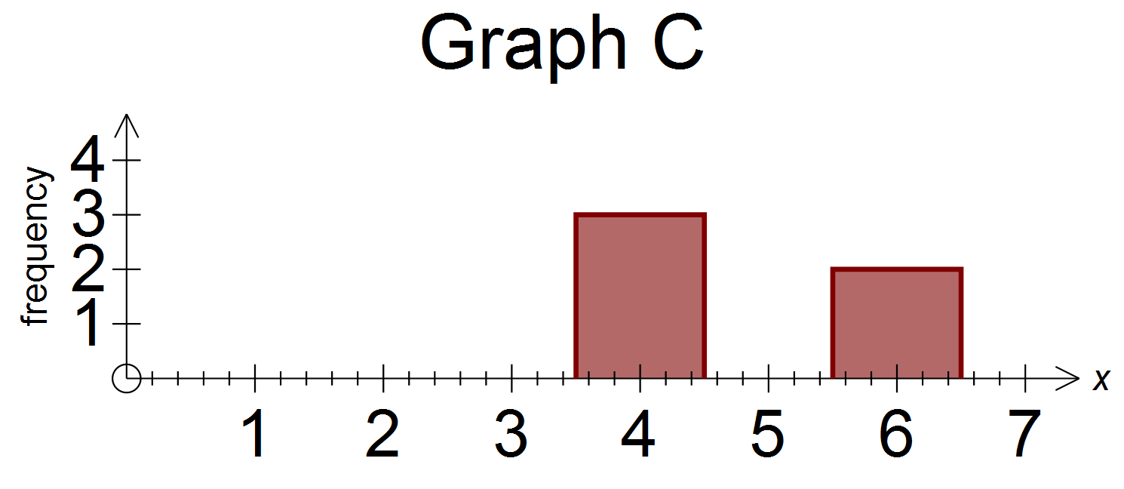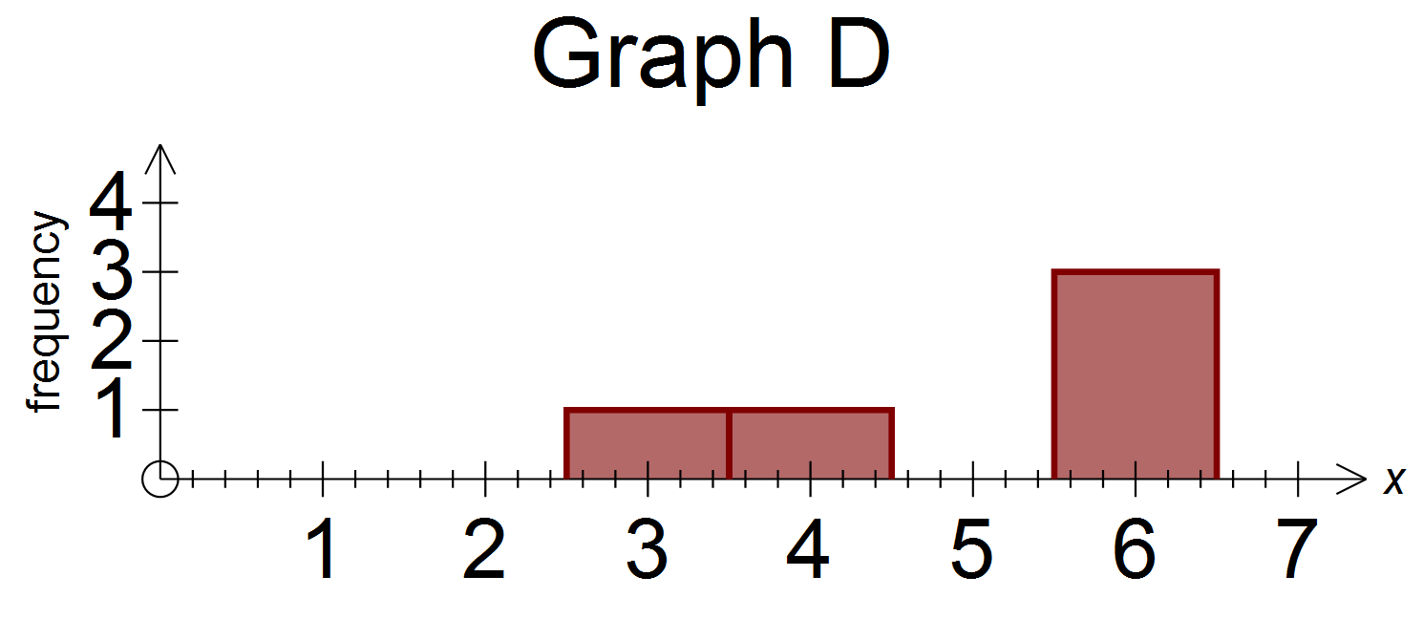

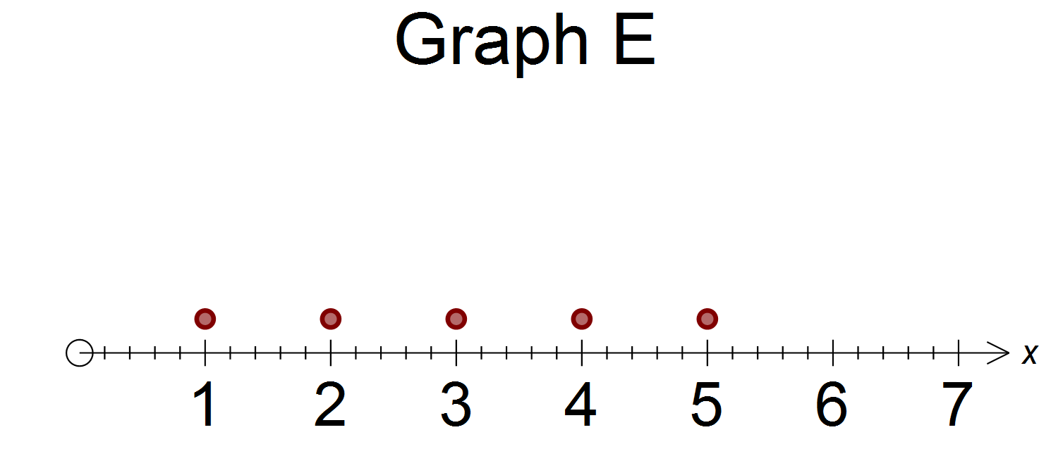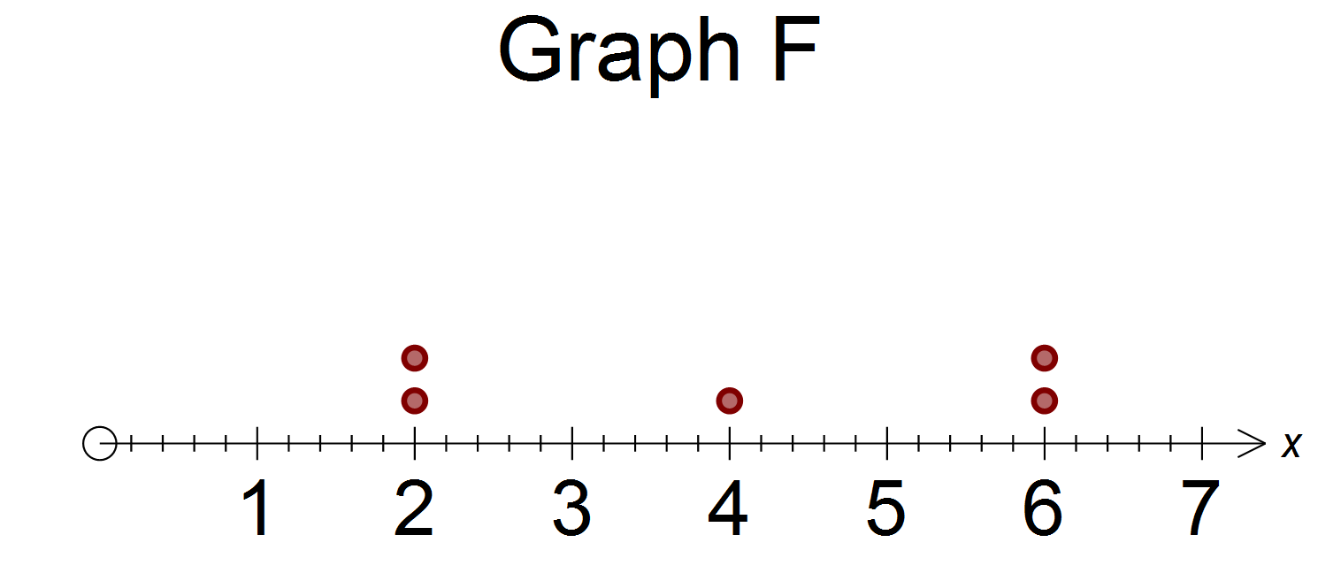

Question 5 (6 marks)

The graph below shows the speed of four vehicles, A, B, C and D, over 20 seconds.

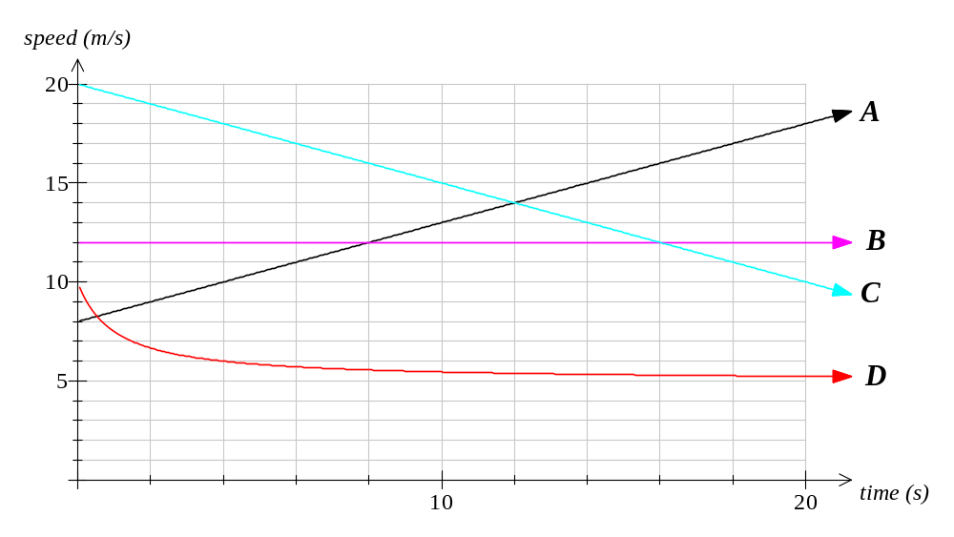(a) Which vehicle had a constant speed over the period? (1 mark)

(b) Name any vehicles that are decelerating. (2 marks)

(c) If the vehicles continue the same motion, what vehicle will be traveling the slowest after 30 seconds? (2 marks)

(d) Which of these graphs has a constant rate of change? (1 mark)

Question 6 (3 marks)

The diagram below of a unit circle shows an angle of 146.3°.

(a) Use the unit circle to give estimates to two decimal places of;

(i) sin 146.3° (1 mark)

(ii) cos 146.3° (1 mark)

(b) Also give an estimate of the cos 33.7°. (1 mark)

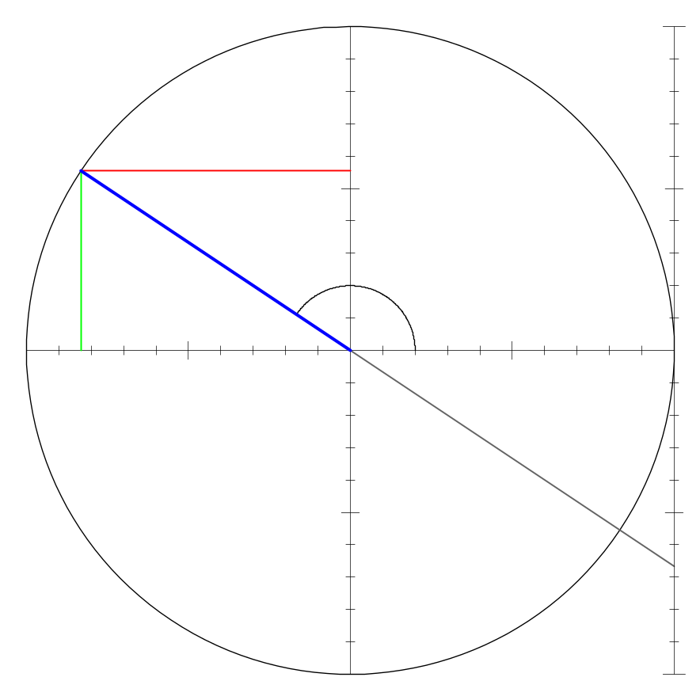

Question 7 (8 marks)

Match the graphs drawn here with their corresponding equations from the set below the graphs:
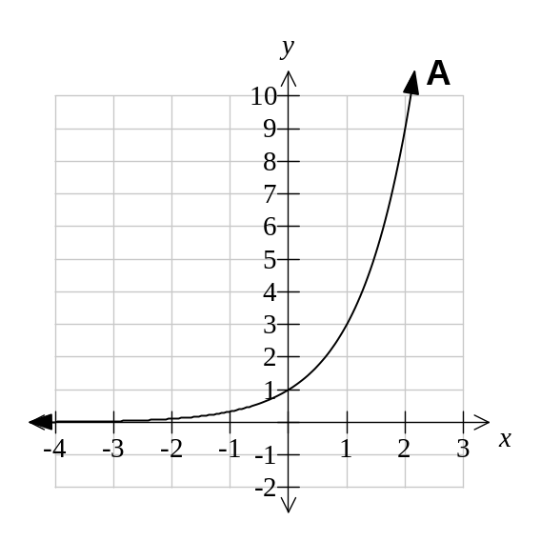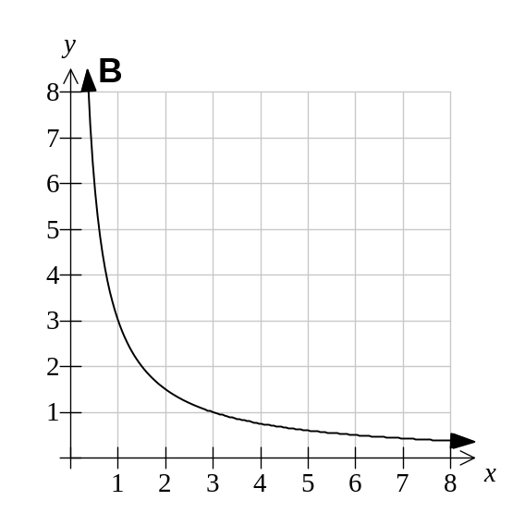

Graph A is equation ______ Graph B is equation ______
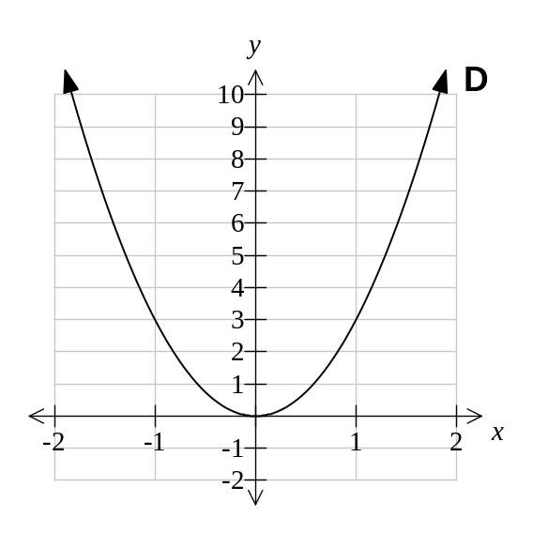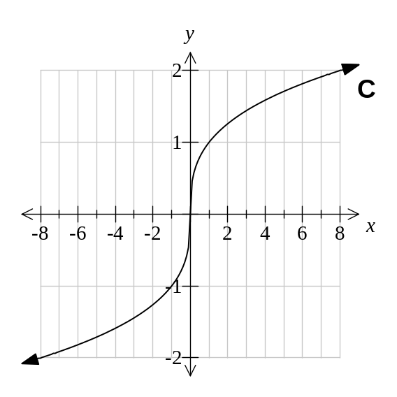

Graph C is equation ______ Graph D is equation ______

Equations:
I : 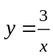 II: 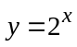 III: 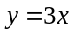 IV: 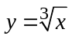

V: 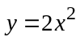 VI: 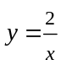 VII: 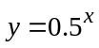 VIII: 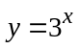

IX: 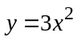 X: 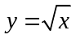 XI: 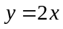 XII: 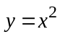
Additional working space

Question number(s): _____________
Additional working space

Question number(s): _____________

